Tech-ni-Fold Micro-Perforator Tool Kiss-Cut Attachment
Converting your Tech-ni-Fold Micro-Perforator to a Kiss-Cutting Device is quick and easy.
Kiss-Cutting both self-adhesive label stock and thicker card stocks is now possible on your folding machine.
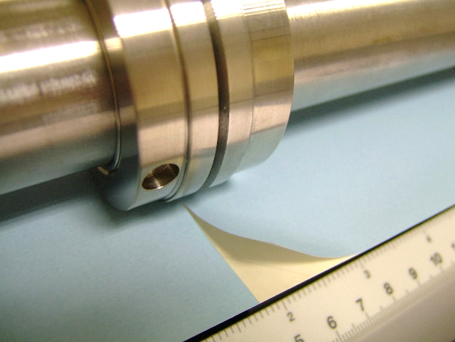

Kiss-Cutting on card stock
Kiss-Cutting on self-adhesive label stock

Instructions
- Setup the Micro-Perforator Blade Holder as you would for a Micro-Perforation job, but instead replace with the supplied Kiss-Cutting Blade
Please take extra care removing the Kiss-Cutting Blade from the packaging.
The Blades are extremely sharp.
- Install the Black Nylon Sleeve to the Female Sleeve Holder component
- Install both the Blade Holder Component and the Nylon Holder Component to the shafts of the machine as per normal installation procedure
- Set the usual shaft pressures according to the stock you are processing through the machine and run a sheet through
- Check the kiss-cut (half-cut) result achieved on the sheet is as required
- Adjust the pressures on the machine to increase or decrease cut penetration
For greater cut depth then experiment with
replacing the Blue Nylon Sleeve for the Black Nylon Sleeve.


